National AI Day

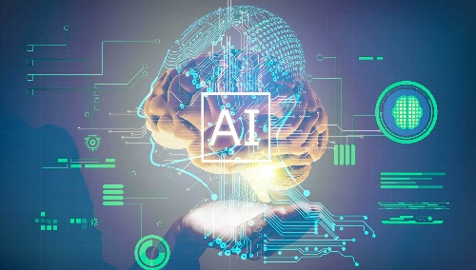

## WHAT IS AI? Computer system capable of performing complex reasoning, making decision, or problem solving.

## WHO IS THE FATHER OF AI? Along with being considered the father of, john McCarthy was a prominent computer scientist and cognitive scientist.

### **Purpose of AI**

### AI works by integrating large amounts of information with fast, iterative processing and smart formulas, permitting the software program to discover immediately patterns or functions in the information. [**AI**](https://zabeelinstitute.ae/ai-artificial-intelligence-course-dubai-abudhabi/) is a wide field of study that includes numerous concepts, techniques as well as modern technology.

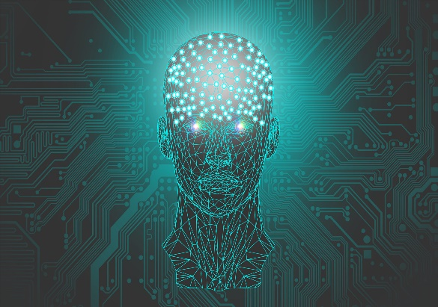

### Boosts decision making

### The basic objective of artificial intelligence is to provide a system for decision-making. This decision-making is based upon rare data as input data as well as will certainly offer synthetic intelligent results like the human mind.

### 2.Artificial intelligence

### The main difference between artificial intelligence and artificial intelligence is that artificial intelligence is mainly worried about precision. Machine learning is the sub-field of expert systems and also it takes data to create the output as it is much more concentrated.

### 3.Imaginative operate in modern technologies

### There is a number of innovations that are utilized to streamline the workflow as well as are easy to integrate throughout the business. These innovations are extremely important and also are playing an essential function in various fields of life.

### 4.Selfhood

### The ultimate goal of an expert system is to surpass the job of humans. In near future, the development of technology will certainly become unmanageable that will certainly result in massive changes in the human lifestyle.

### 5.Organization procedure optimization

### Service has the essential integrity in the economic climate of any nation. The business process optimization is accomplished by streamlining the job and also eliminating the redundancies that inevitably lead to the improvement of the business.

### 6.Health care

### It one of the most crucial fields where the expert system has revolutionized the field. A lot of medical care organizations are making use of artificial intelligence makes for better and quick diagnoses of the illness in the patients.

### 7.Provide monetary solutions

### The expert system has actual played a significant function in economic services. It is used in fraud discovery, threat administration, property monitoring, and insurance besides many other sub-fields of financial solutions. There is almost no sub-field left without making use of expert system applications.

### 8.Human Resources & Recruitment

### The expert system in HR & employment is to boost-up the speed as well as the accuracy of decision making and make the option a lot more reputable as well as exact.

### 9.Automotive

## An expert system has a big effect on the auto industry. You will certainly locate it anywhere from car manufacturing sector to motorist surveillance and motorist recognition. **The history of artificial intelligence:**

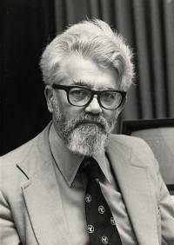

### The idea of “artificial intelligence” goes back thousands of years, to ancient philosophers considering questions of life and death. In ancient times, inventors made things called “automatons” which were mechanical and moved independently of human intervention. The word “[automaton](https://www.britannica.com/technology/automaton)” comes from ancient Greek, and means “acting of one’s own will.” One of the earliest records of an automaton comes from 400 BCE and refers to a mechanical pigeon created by a friend of the philosopher Plato. Many years later, one of the most famous automatons was created by [Leonardo da Vinci around the year 1495](https://www.history.com/news/7-early-robots-and-automatons).

### So while the idea of a machine being able to function on its own is ancient, for the purposes of this article, we’re going to focus on the 20th century, when engineers and scientists began to make strides toward our modern-day AI.

### **Groundwork for AI:**

### 1900-1950In the early 1900s, there was a lot of media created that cantered around the idea of artificial humans. So much so that scientists of all sorts started asking the question: is it possible to create an artificial brain? Some creators even made some versions of what we now call “robots” (and the word was coined in a Czech play in 1921) though most of them were relatively simple. These were steam-powered for the most part, and some could make facial expressions and even walk.

### Dates of note:

### **1921:** Czech playwright Karel Čapek released a science fiction play “[Rossum’s Universal Robots](https://www.gutenberg.org/files/59112/59112-h/59112-h.htm)” which introduced the idea of “artificial people” which he named robots. This was the first known use of the word.

### **1929:** Japanese professor Makoto Nishimura built the first Japanese robot, named Gakutensoku.

### **1949:** Computer scientist Edmund Callis Berkley published the book “[Giant Brains, or Machines that Think](https://monoskop.org/images/b/bc/Berkeley_Edmund_Callis_Giant_Brains_or_Machines_That_Think.pdf)” which compared the newer models of computers to human brains.

### **Birth of AI: 1950-1956**

### This range of time was when the interest in AI really came to a head. Alan Turing published his work “Computer Machinery and Intelligence” which eventually became The Turing Test, which experts used to measure computer intelligence. The term “artificial intelligence” was coined and came into popular use.

### Dates of note:

### **1950:** Alan Turing published “[Computer Machinery and Intelligence](https://academic.oup.com/mind/article/LIX/236/433/986238)” which proposed a test of machine intelligence called The Imitation Game.

### **1952:** A computer scientist named [Arthur Samuel](https://history.computer.org/pioneers/samuel.html) developed a program to play checkers, which is the first to ever learn the game independently.

### **1955:**[John McCarthy](https://computerhistory.org/profile/john-mccarthy/#:~:text=McCarthy%20coined%20the%20term%20%E2%80%9CAI,programming%20language%20lisp%20in%201958.) held a workshop at Dartmouth on “artificial intelligence” which is the first use of the word, and how it came into popular usage.